CSC2001F
Assignment 1
Adam Foflonker
FFLADA001

Foreword
- “make array” builds and runs the array implementation.
- “make bst” builds and runs the bst implementation.
Object-Oriented Design
- BinarySearchTree is a basic implementation of a binary search tree.

- BinarySearchTree.Node is a node in the binary search tree.

- BinarySearchTree.BSTIterator is an iterator allowing inorder traversal of the tree in range-based for-loops.
- The Console class was written as a wrapper around System.out and System.in.
- GenericsKbApp is the common behaviour between the bst and array implementations of the app. It allows for the specification of an enum, KnowledgeBaseType which specifies whether the app should use the array or bst implementation of the KnowledgeBase. This approach was taken to ensure that the array and bst implementations maintain the same front-end interface and support the same functionality – the only difference between the two interfaces is the backend data type used to store the KnowledgeBase.
- GenericsKbArrayApp is the entry-point for the array implementation of GenericsKbApp.
- GenericsKbBSTApp is the entry-point for the bst implementation of GenericsKbApp.
- KnowledgeBase is the abstract base-class for all knowledge base implementations.
- KnowledgeBaseArray is the array implementation of the super-class KnowledgeBase, which implements the knowledge base as a traditional array.
- KnowledgeBaseBST is the bst implementation of the super-class KnowledgeBase, which implements the knowledge base as a binary search tree.
- The Statement class represents a single statement-entry in the knowledge base which contains a term, sentence and confidence score. A KnowledgeBase is a collection of Statements.

Testing
Loading knowledge base from textfile
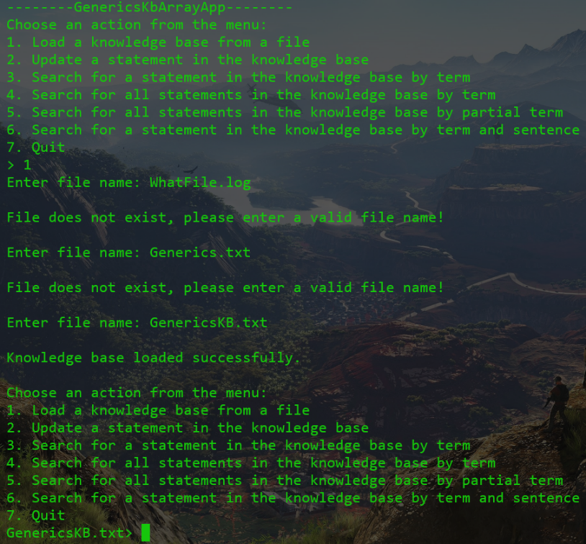
Attempting to update a statement in the knowledge base with a lower confidence score. A user-inputted confidence score exceeding 1.0 or less than 0.0 will be clamped between 0.0 and 1.0.
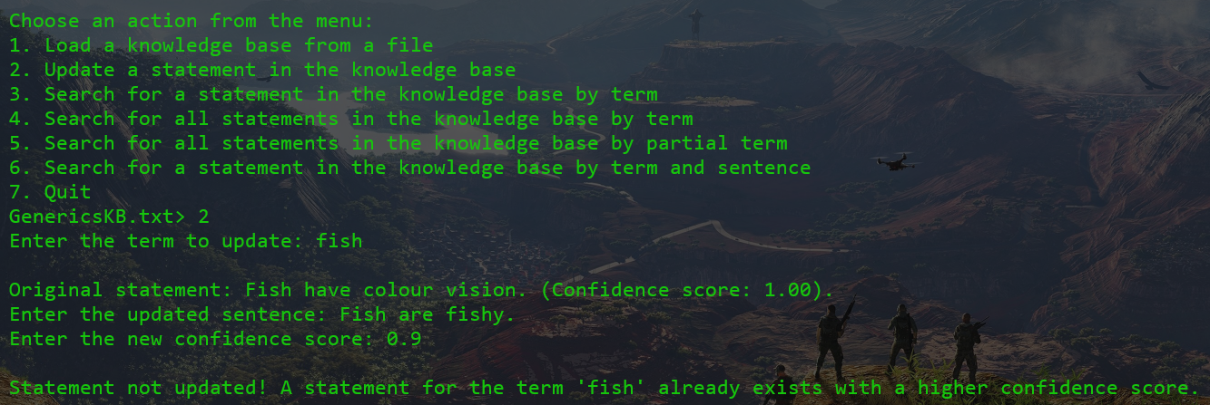
Searching for existing and non-existing statements in the knowledge base
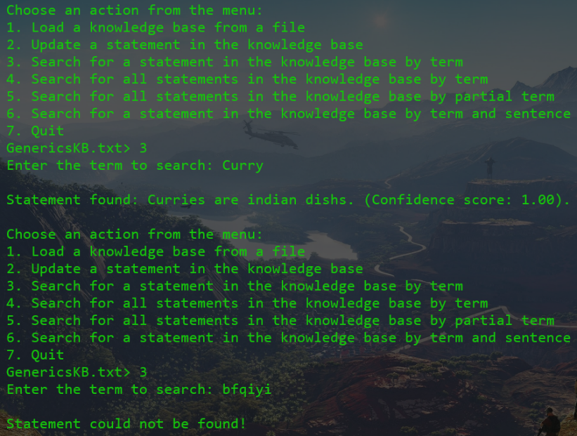

Search for all statements matching a term in the knowledge base
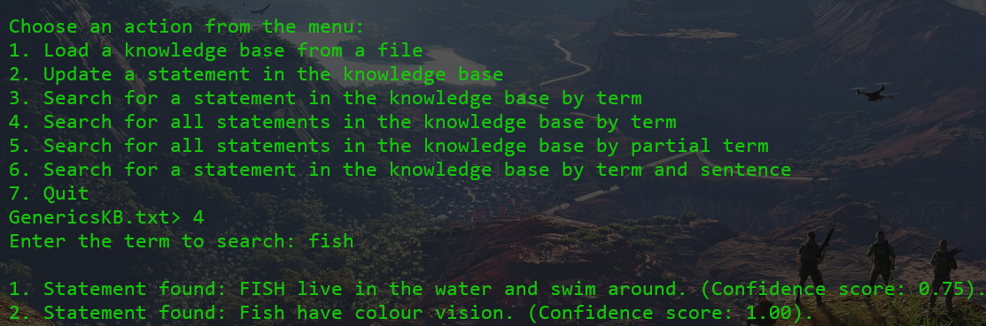
Searching for all statements in the knowledge base matching a partial term. This matches all terms beginning with the given partial term.
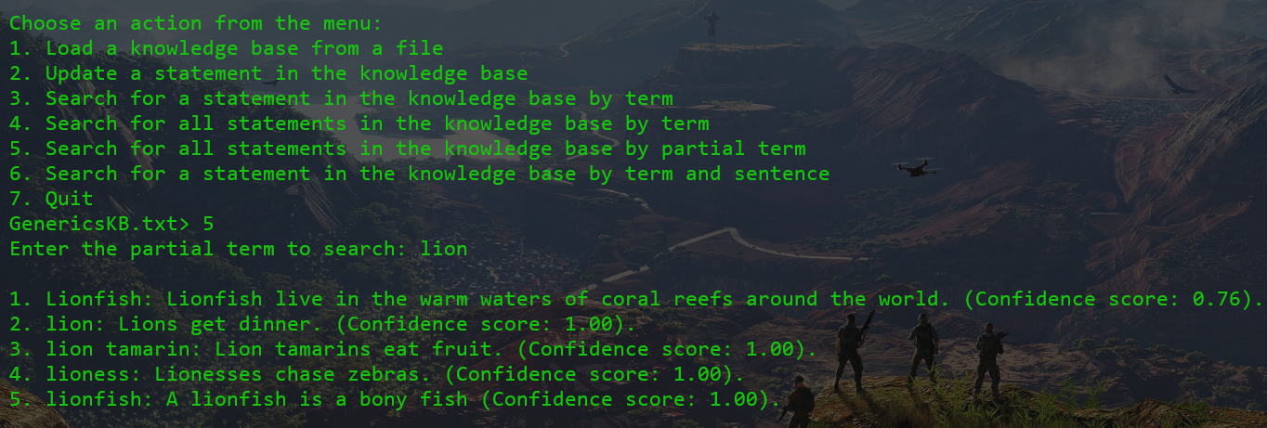
Searching the knowledge base by term and sentence.
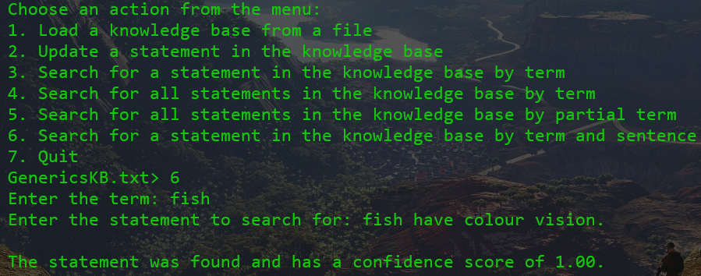
Updating the loaded knowledge base from another knowledge base textfile. This operation does not permit the same knowledge base to be loaded twice.
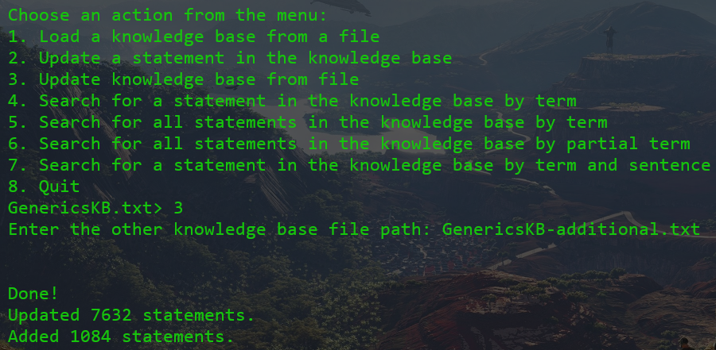
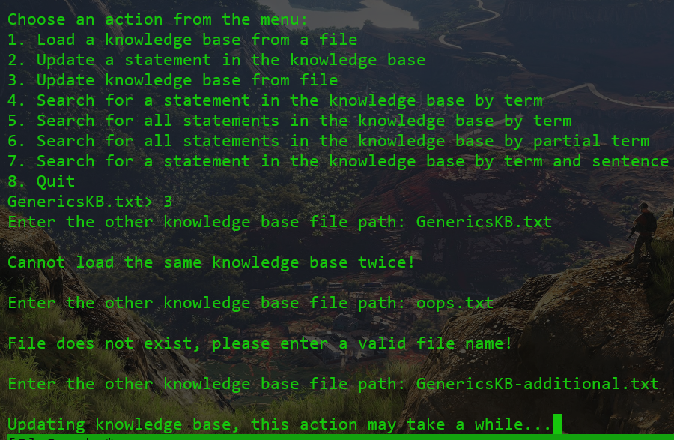

Creativity
- Enhanced search functionality (option 5) to return all statements matching a specific term, as opposed to option 4 which only returns the one with the highest confidence score.
- Enhanced search functionality (option 6) to search by partial term, this search returns all statements wherein the first part of the term matches the partial term given.
- Updating the knowledge base from a file returns the number of statements updated and added to the knowledge base loaded in memory.
- The codebase exhibits modularity having a singular common behaviour between both applications. This allows changes to be made to both bst and array implementations of the app by only modifying one source file.

Git log
0: commit a4f011bc94bb9ff3a96e826dfe8301717f8073d6
1: Author: Adam <87928802+DnA-IntRicate@users.noreply.github.com>
2: Date: Mon Mar 17 12:29:20 2025 +0200
3:
4: Update KB from textfile
5:
6: commit 4f2b03f05f46e1f7fe0b24866b336592c42ef473
7: Author: Adam <87928802+DnA-IntRicate@users.noreply.github.com>
8: Date: Mon Mar 17 09:31:02 2025 +0200
9:
...
175: Author: Adam <87928802+DnA-IntRicate@users.noreply.github.com>
176: Date: Mon Mar 3 11:19:14 2025 +0200
177:
178: Create Assignments dir
179:
180: commit 49760da2adf21553f07f76764dd0b9dfe40dc75b
181: Author: Adam <87928802+DnA-IntRicate@users.noreply.github.com>
182: Date: Mon Mar 3 11:18:48 2025 +0200
183:
184: Update .editorconfig to correctly support Makefiles

